**COCHIN UNIVERSITY OF SCIENCE AND TECHNOLOGY**

**COCHIN UNIVERSITY COLLEGE OF ENGINEERING KUTTANADU, PULINCUNNOO,ALLAPHUZHA**

**KERALA-688504**



**MAY 2021**

SEMINAR REPORT ON

**TRAFFIC PREDICTION FOR INTELLIGENT TRANSPORTATION SYSTEM USING MACHINE LEARNING**

*Submitted on partial fulfilment of the requirement for the award of the degree in Master of Computer Applications from Cochin University of Science and Technology*

Submitted by

**RAHUL KUMAR(Reg No: 38119227)**

DEPARTMENT OF MASTER OF COMPUTER APPLICATIONS

2019-2022

**COCHIN UNIVERSITY OF SCIENCE AND TECHNOLOGY**

**COCHIN UNIVERSITY COLLEGE OF ENGINEERING KUTTANAD**



**CERTIFICATE**

This is to certify that this project report entitled “**TRAFFIC PREDICTION FOR INTELLIGENT TRANSPORTATION SYSTEM*”*** is a bonafide record on partial fulfilment for the degree of the Master of Computer Applications to the Cochin University of Science and Technology through Department of Computer Applications, Cochin University College of Engineering Kuttanadu Alappuzha done by RAHUL KUMAR *(Reg.NO:38119227)* in the year 2021.

**Seminar Guide Head of the department**

Ms. Fanny May Joseph Mr. Harikrishnan D

**Internal Examiner**

**DECLARATION**

I hereby declare that the project entitled “**TRAFFIC PREDICTION FOR INTELLIGENT TRANSPORTATION SYSTEM*”*** submitted to the Department of Computer Applications Cochin University College Of Engineering Kuttanadu in the partial fulfilment of the requirements for the award of Degree in Master Of Computer Applications is a record of original work done by me under the guidance of **Ms. Fanny May Joseph, Asst. Professor(MCA Dept),** during my period of study in Cochin University College Of Engineering Kuttanadu.

Place: CUCEK

Date: RAHUL KUMAR

**ACKNOWLEDGEMENT**

I am thankful to god almighty for the blessings in the successful completion of our seminar **“*TRAFFIC PREDICTION FOR INTELLIGENT TRANSPORTATION SYSTEM*”**. I would like to record my profound gratitude to ***Dr. Joseph Kutty Jacob***, Principal and ***Mr.Harikrishnan D***, Head of the Department, MCA Cochin University College of Engineering who has deeply inspired me to do my seminar.

It’s grateful to express my thanks to **Ms. Fanny May Joseph**, Assistant Professor in MCA Department my seminar guide, Cochin University College of Engineering Kuttanadu, because their effective guidance, constructive criticism and innovative and useful stream of suggestions that helped me to complete my seminar.

I am thankful to various resources that provide requirements for my seminar, because requirements are backbone of every seminar.

I am also thankful to my teachers, friends, family members, for their support and prayer for me to complete my seminar.

**ABSTRACT**

This paper aims to develop a tool for predicting accurate and timely traffic flow Information. Traffic Environment involves everything that can affect the traffic flowing on the road, whether it’s traffic signals, accidents, rallies, even repairing of roads that can cause a jam. If we have prior information which is very near approximate about all the above and many more daily life situations which can affect traffic then, a driver or rider can make an informed decision. Also, it helps in the future of autonomous vehicles. In the current decades, traffic data have been generating exponentially, and we have moved towards the big data concepts for transportation.Available prediction methods for traffic flow use some traffic prediction models and are still unsatisfactory to handle real-world applications.

**CONTENTS**

Table of Contents

1. CHAPTER 1………………………………………………………………………….....1

INTRODUCTION………………………………………………………………2

1.1 Why ITS is important………………………………………………………2

1. CHAPTER 2…………………………………………………………………….……...3

2.2 Intelligent Transport Technolgies....…………………………………………..4

2.2.1 Wireless Communications.……………………………………………….…5

2.2.2 Computational Technolgies.………………………………………………...5

2.2.3 Floating Car Data…………………………………………………….……...6

2.2.4 Inductive Loop Detection and Sensing Technologies………………….……7

2.2.5 Video Vehicle Detection…………………………………………….………8

3. CHAPTER 3…………………………………………………………………………….9

3.1 Intelligent Transport Application...……………………………………………10

3.1.1 Emergency Vehicle Notification Detection…………………………………11

3.1.2 Automatic Road Enforcement…………………………………………….....12

3.1.3 Variable Speed Limit………………………………………………………..12

3.1.4 Collision Avoidance System………………………………………………...13

3.1.5 Dynamic Traffic Light Sequence……………………………………………14

4. CHAPTER 4………………………………………………………………………….…15

4 Design……………………………………………………………………….…...15

1. CHAPTER 5…………………………………………………………………………….16

5.1 Implementation………………………………………………………………...16

5.2 Results…………………………………………………………………...…….17

6. CHAPTER 6……………………………………………………………………………18

6.1 Conclusion…………………………………………………………………….18

6.2 Future Work…………………………………………………………………..19

REFERENCES ……………………………………………………………….…………..19

7. List Of Figures …………………………………………………………..4

7.1 Intelligent Transport Technolgies....…………………………………………..4

7.2 Wireless Communications.……………………………………………….…...5

7.3 Computational Technolgies.…………………………………………………..5

7.4 Floating Car Data…………………………………………………….………..6

7.5 Inductive Loop Detection and Sensing Technologies………………….……..7

7.6 Video Vehicle Detection…………………………………………….………...8

7.7Intelligent Transport Application...……………………………………………10

7.8 Emergency Vehicle Notification Detection…………………………………..11

7.9 Automatic Road Enforcement…………………………………………….......12

7.10 Variable Speed Limit………………………………………………………..12

7.11 Collision Avoidance System………………………………………………...13

7.12 Dynamic Traffic Light Sequence……………………………………………14

8 . Tables I………………………………………………………………………………...17

**CHAPTER 1**

**INTRODUCTION**

* Intelligent Transport System refers to information and communication technology to transport infrastructure and vehicles , that improves transport outcomes:

1. Transport Safety

2. Transport Productivity

3. Travel Reliability

4. Informed Travel Choices

5. Social Equity

6. Environmental Performance

7. Network Operation Resilience

* It helps the riders and drivers to make better travel judgement to alleviate traffic congestion, improve traffic operation efficiency, and reduce carbon emissions .
* The development and deployment of Intelligent Transportation System (ITSs) provide better accuracy for Traffic flow prediction.
* It is deal with as a crucial element for the success of advanced traffic management systems, advanced public transportation systems, and traveller information systems.

**1.1** **WHY ITS IS IMPORTANT**

* Interest in ITS comes from the problems caused by traffic congestion and a synergy of new information technology for simulation, real-time control, and communications networks.
* Traffic congestion has been increasing worldwide as a result of increased motorization, urbanization, population growth, and changes in population density.

Page : 1

* Many of the proposed ITS systems also involve surveillance of the roadways.

Page: 2

**CHAPTER 2**

**INTELLIGENT TRANPORT TECHNOLOGIES**

ITS provides both theory and implementation for a range of application. The most frequent applications utilizing ITS are:

1. **Wireless Communication**

* Radio modem communication on UHF and VHF frequencies are widely used for short and long range communication within ITS.

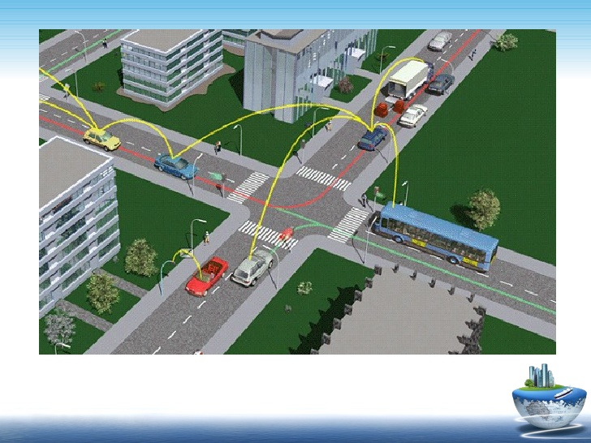

Fig: Wireless communication

* Short-range communications (less than 450 meters) can be accomplished using IEEE 802.11 protocols. Theoretically, the range of these protocols can be extended using Mobile ad-hoc networks or Mesh networking.

Page: 3

* Longer range communications have been proposed using infrastructure networks such as WiMAX (IEEE 802.16), Global System for Mobile Communications (GSM), or 3G.

1. **Computational Technologies**

* A typical vehicle in the early 2000s would have between 20 and 100 individual networked microcontroller/Programmable logic controller modules with non-real-time operating systems.

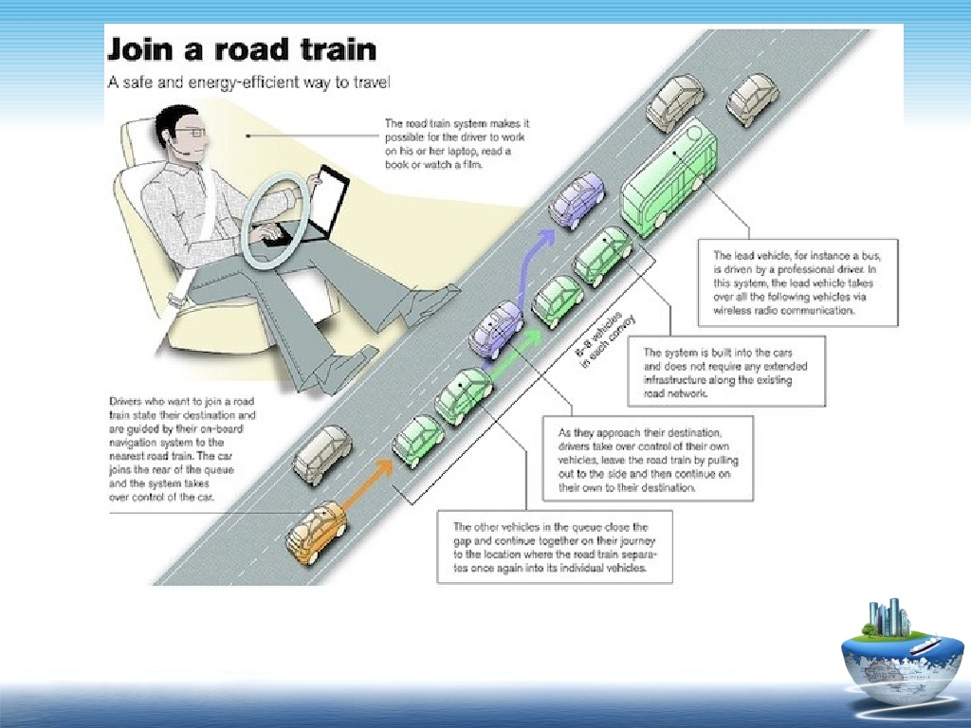Fig: Computational Technologies

* The current trend is toward fewer, more costly microprocessor modules with hardware memory management and Real-Time Operating Systems.

Page : 4

* The new embedded system platforms allow for more sophisticated software applications to be implemented, including model-based process control, artificial intelligence, and ubiquitous computing.
* Perhaps the most important of these for Intelligent Transportation Systems is artificial intelligence.

1. **Floating Car Data / Floating Cellular Data**

* "Floating car" or "probe" data collection is a set of relatively lowcost methods for obtaining travel time and speed data for vehicles traveling along streets, highways, freeways, and other transportation routes.
* Broadly speaking, three methods have been used to obtain the raw data:

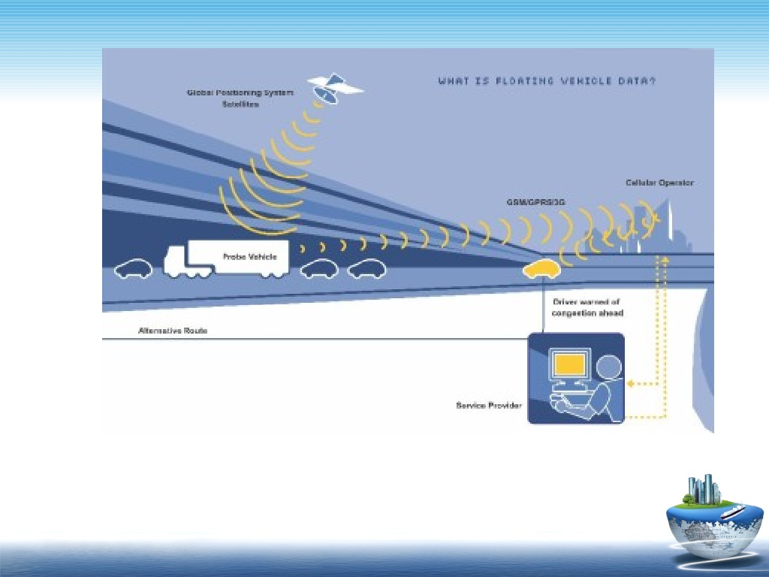

Fig: Floating Car Data

1 .Triangulation Method Page: 5

* In the mid 2000s, attempts were made to use mobile phones as anonymous traffic probes. As a car moves, so does the signal of any mobile phones that are inside the vehicle. By measuring and analyzing network data using triangulation, pattern matching or cell-sector statistics (in an anonymous format), the data was converted into traffic flow information.

2 .Vehicle Re-Identification

* This method requires sets of detectors mounted along the road. In this technique, a unique serial number for a device in the vehicle is detected at one location and then detected again (re-identified) further down the road.

Travel times and speed are calculated by comparing the time at which a specific device is detected by pairs of sensors. This can be done using the MAC (Machine Access Control) addresses from Bluetooth devices, or using the RFID serial numbers from Electronic Toll Collection (ETC) transponders.

3. GPS Based Methods

* An increasing number of vehicles are equipped with in-vehicle GPS (satellite navigation) systems that have two-way communication with a traffic data provider. Position readings from these vehicles are used to compute vehicle speeds.

1. **Inductive Loop Detection and Sensing Technologies**

* Technological advances in telecommunications and information technology, coupled with state-of-the-art microchip, RFID (Radio Frequency Identification), and inexpensive intelligent beacon sensing technologies, have enhanced the technical capabilities that will facilitate motorist safety benefits for intelligent transportation systems globally.

Page: 6

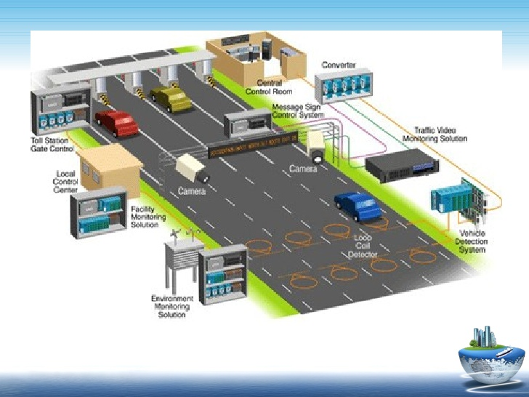 Fig: InductiveLoop Detection

* Inductive loops can be placed in a roadbed to detect vehicles as they pass through the loop's magnetic field. The simplest detectors simply count the number of vehicles during a unit of time (typically 60 seconds in the United States) that pass over the loop.

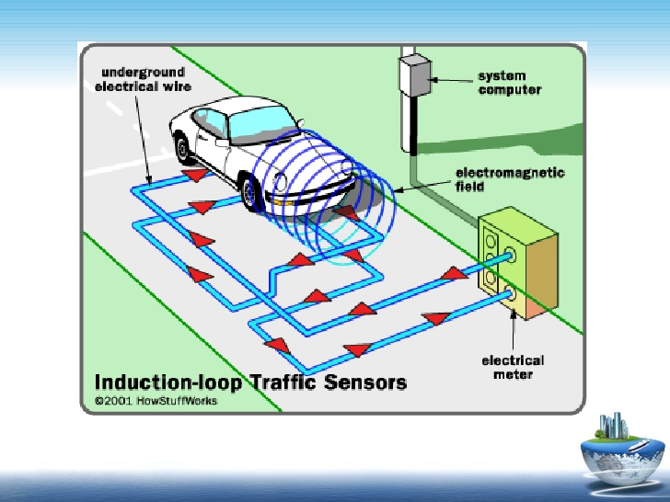

Page: 7

1. **Video Vehicle Detection**

* Traffic flow measurement and automatic incident detection using video cameras is another form of vehicle detection. Since video detection systems such as those used in automatic number plate recognition do not involve installing any components directly into the road surface or roadbed, this type of system is known as a "nonintrusive" method of traffic detection.

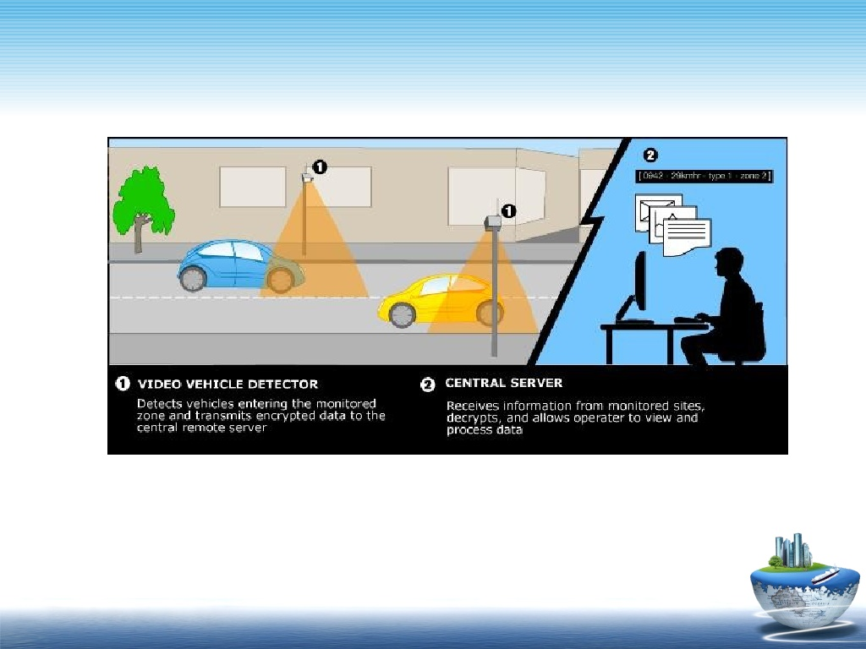

Fig: Video Vehicle Detection

* Video from black-and-white or color cameras is fed into processors that analyze the changing characteristics of the video image as vehicles pass. The cameras are typically mounted on poles or structures above or adjacent to the roadway.

Page: 8

**CHAPTER 3**

**INTELLIGENT TRANSPORT APPLICATION**

3.1 Emergency Vehicle Notification System

* The alerts are broadcast to the geographic area affected by an emergency. This means that if an alert is sent to a zone in New York, WEA-capable mobile devices in that zone can receive the alert, even if they are roaming or visiting from another state.
* A method for notifying traffic of an approaching emergency vehicle is described. ... A signal is emitted from the emergency vehicle, which is detected by a receiver along the roadway. The receiver causes a light to flash and a relay signal to be sent to the next alert unit along the roadway.

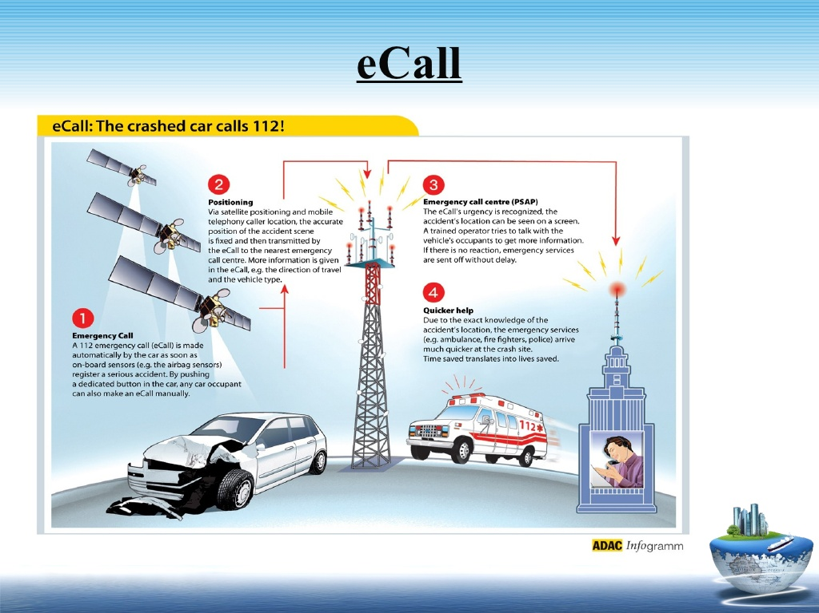

Fig: Emeregency Vehicle Notification System

Page: 9

3.2 Automatic Road Enforcement

* Speed cameras that identify vehicles traveling over the legal speed limit. Many such devices use radar to detect a vehicle's speed or electromagnetic loops buried in each lane of the road.
* Red light cameras that detect vehicles that cross a stop line or designated stopping place while a red traffic light is showing.
* Bus lane cameras that identify vehicles traveling in lanes reserved for buses. In some jurisdictions, bus lanes can also be used by taxis or vehicles engaged in car pooling.
* Level crossing cameras that identify vehicles crossing railways at grade illegally.
* Double white line cameras that identify vehicles crossing these lines.
* High-occupancy vehicle lane cameras for that identify vehicles violating HOV requirements.

Page: 10

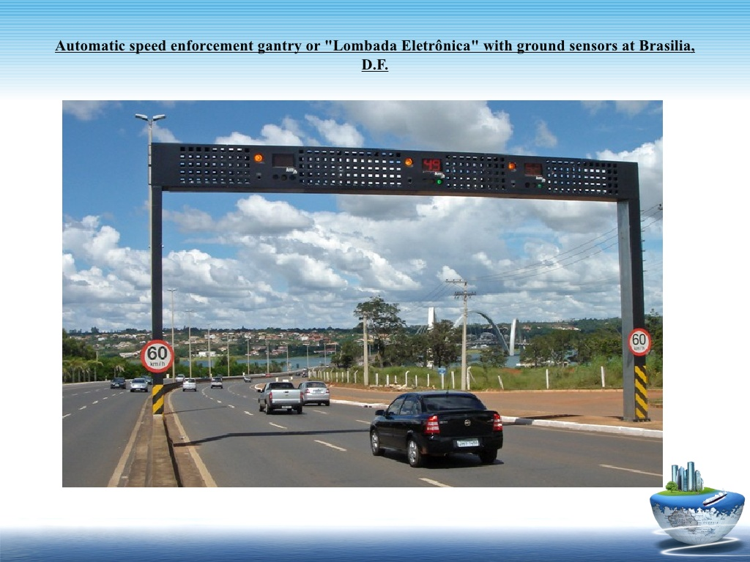Fig: Automatic Road Enforcement

3.3 Variable Speed Limits

* A variable speed limit is a flexible restriction on the rate at which motorists can drive on a given stretch of road. The speed limit changes according to the current environmental and road conditions and is displayed on an electronic traffic sign. Signs typically indicate a maximum speed and may also list the minimum.
* A speed limit displayed inside a red circle is legally enforceable. If you go over the speed limit, you're breaking the law and could receive a fine. ... If no speed limits are displayed then the national speed limit applies.

Page: 11

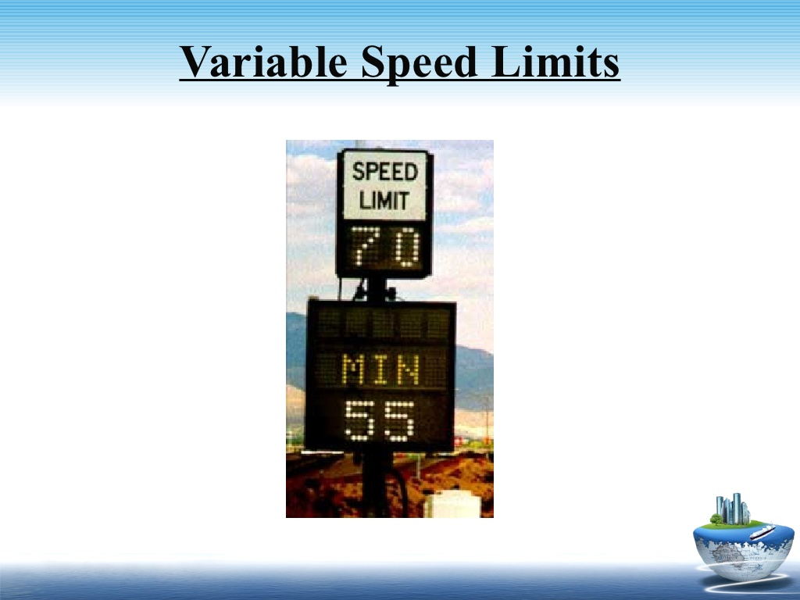

Fig: Variable Speed Limit

3.4 Collision Avoidance System

* CAS, also known as precrash system, forward collision warning system, or collision mitigating system, uses radar or other sensors (eg, laser and camera) to detect an imminent crash, and then provides a warning to the driver or takes braking/steering action directly.
* A collision avoidance system, also known as a driver assistance system, is a safety system designed to prevent a collision or decrease its severity in the few seconds before it occurs.

Page: 12

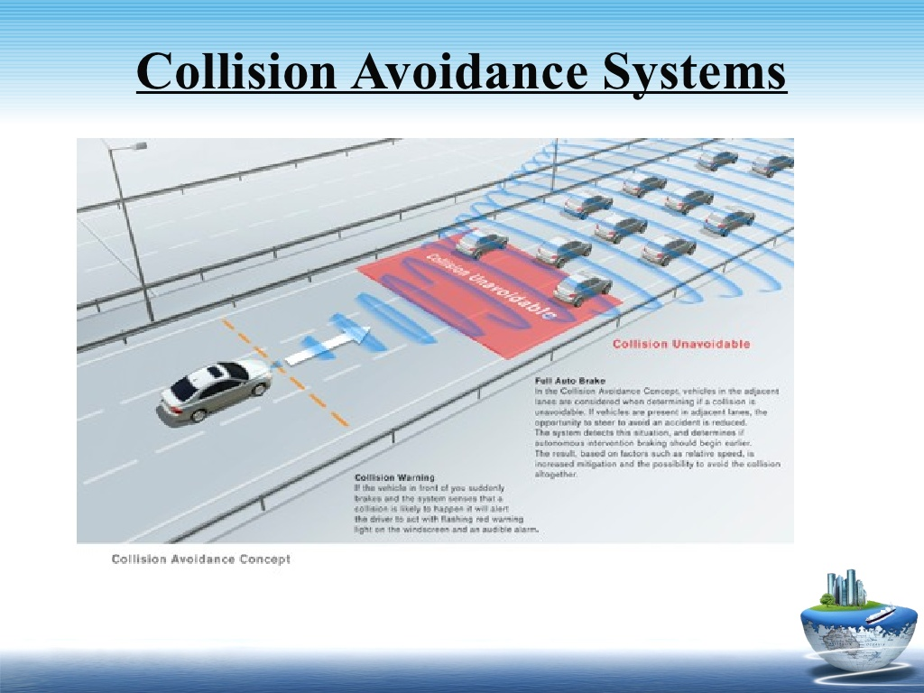 Fig: Collision Avoidance System

3.5 Dynamic Traffic Light Sequence

* It provides an efficient time management scheme, in which a dynamic time schedule is worked out in real time for the passage of each traffic column.
* In almost all modern cities around the world, traffic congestion is a severe problem. Existing adaptive traffic control systems utilized traffic phase and phase duration either considering traffic density or vehicular waiting time and hunger level, without any optimization.

Page: 13

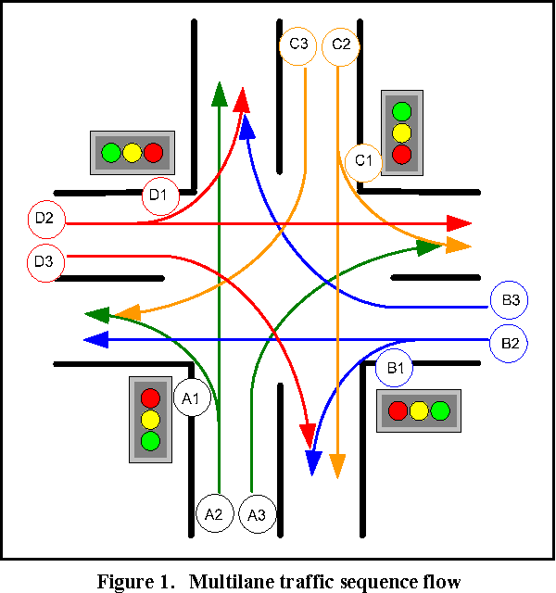

Fig: Dynamice Traffic Light Sequence

Page: 14

**CHAPTER 4**

**DESIGN**

*The application was created with minimum buttons, so that user can easily use the applications without any confusion. Also the interface is kept light so that the application loads fastly and doesn’t create any problem to user. The geo coordinates of the application are displayed in a Toast View.*

* **Name of Application:- My application**
* **Compatibility:- Android 6.01 and above**
* **Compatibility:- Android 6.01 and above**

Page: 15

**CHAPTER 5**

**IMPLEMENTATION AND RESULT**

5.1 Implementation

* We have applied and tested different machine algorithms for achieving higher efficiency and accurate results. To identify classification and regression we have used a Decision Tree Algorithm (DT).The goal of this method is to predict the value of the target variables.
* Decision tree learning represents a function that takes as input a vector of attributes value and return a ”Decision ” a single output value.

1) Created the application which can provide us the GPS coordinates.

2) Perform the proposed algorithm

3) Evaluate the matrix for the dataset

4) Divide the the dataset into training and testing.

5) Analyse different machine learning algorithms.

6) Predict the 45 min interval parameters through machine learning algorithm

7) Conclude about the traffic congestion

5.2 Result

Table I shows the results of performance of the models obtained through different machine learning algorithms that are discussed in this paper. In this table we defined the various attributes like Accuracy, Precision, Recall and Time Taken.

Page: 16

Table I

|  |  |  |  |  |
| --- | --- | --- | --- | --- |
| Algorithm | Accuracy | Precision | Recall | Time |
| Decision Tree | 88% | 88.56% | 82% | 108.4sec |
| SVM | 88% | 87.88% | 80% | 94.1sec |
| Random Forest | 91% | 88.88% | 82% | 110.1sec |

Page:17

**CHAPTER 6**

**Conclusion And Future Work**

6.1 Conclusion

* Although deep learning and genetic algorithm is an important problem in data analysis, it has not been dealt with extensively by the ML community.

6.2 Future Work

* The proposed algorithm gives higher accuracy than the existing algorithms also, It improves the complexity issues throughout the dataset.
* . Also we have planned to integrate the web server and the application. Also the things algorithms will be further improved to much more higher accuracy.

REFERENCES

[1] Fei-Yue Wang et al. Parallel control and management for intelligent transportation systems: Concepts, architectures, and applications. IEEE Transactions on Intelligent Transportation Systems, 2010.

[2] Yongchang Ma, Mashrur Chowdhury, Mansoureh Jeihani, and Ryan Fries. Accelerated incident detection across transportation networks using vehicle kinetics and support vector machine in cooperation with infrastructure agents. IET intelligent transport systems, 4(4):328–337, 2010.

[3] Rutger Claes, Tom Holvoet, and Danny Weyns. A decentralized approach for anticipatory vehicle routing using delegate multiagent systems. IEEE Transactions on Intelligent Transportation Systems, 12(2):364–373, 2011.

[4] Mehul Mahrishi and Sudha Morwal. Index point detection and semantic indexing of videos - a comparative review. Advances in Intelligent Systems and Computing, Springer, 2020.

Page : 18

[5] Joseph D Crabtree and Nikiforos Stamatiadis. Dedicated short-range communications technology for freeway incident detection: Performance assessment based on traffic simulation data. Transportation Research Record, 2000(1):59–69, 2007

[6] H Qi, RL Cheu, and DH Lee. Freeway incident detection using kinematic data from probe vehicles. In 9th World Congress on Intelligent Transport SystemsITS America, ITS Japan, ERTICO (Intelligent Transport Systems and Services-Europe), 2002.

[7] Z. Zhao, W. Chen, X. Wu, P. C. Y. Chen, and J. Liu. Lstm network: a deep learning approach for short-term traffic forecast. IET Intelligent Transport Systems, 11(2):68–75, 2017.

[8] C. Zhang, P. Patras, and H. Haddadi. Deep learning in mobile and wireless networking: A survey. IEEE Communications Surveys Tutorials, 21(3):2224–2287, thirdquarter 2019.

[9] Chun-Hsin Wu, Jan-Ming Ho, and D. T. Lee. Travel-time prediction with support vector regression. IEEE Transactions on Intelligent Transportation Systems, 5(4):276–281, Dec 2004.

[10] Yan-Yan Song and LU Ying. Decision tree methods: applications for classification and prediction. Shanghai archives of psychiatry, 27(2):130, 2015.

[11] Yiming He, Mashrur Chowdhury, Yongchang Ma, and Pierluigi Pisu. Merging mobility and energy vision with hybrid electric vehicles and vehicle infrastructure integration. Energy Policy, 41:599–609, 2012.

[12] Jason Brownlee. Bagging and random forest ensemble algorithms for machine learning. Machine Learning Algorithms, pages 4–22, 2016.

Page: 19

THANK YOU

**……………………………………………………………………………………**

Page: 20